**Final topology**

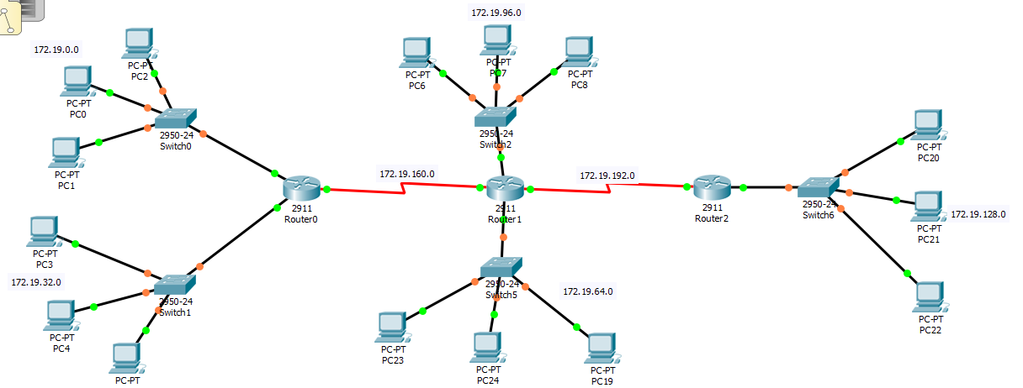

**TAKING Router 1**

* 3 connection
* 2 with switches and 1 serial connection

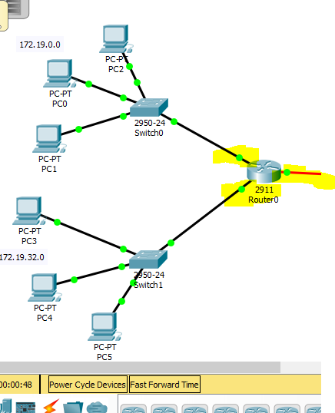

How to assign gateway address to each interface/connection

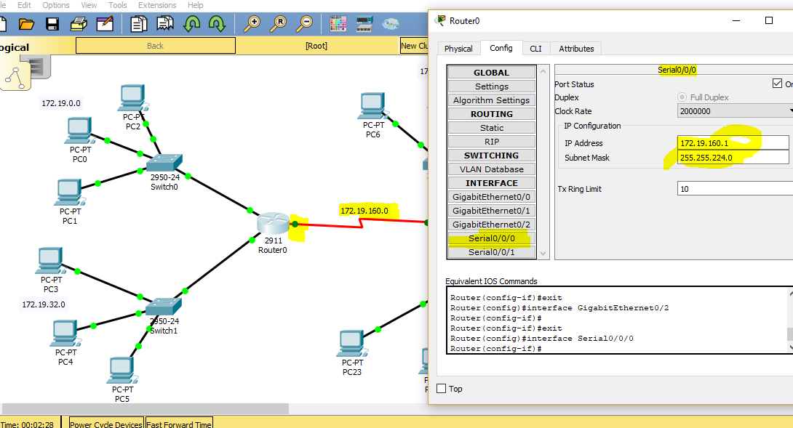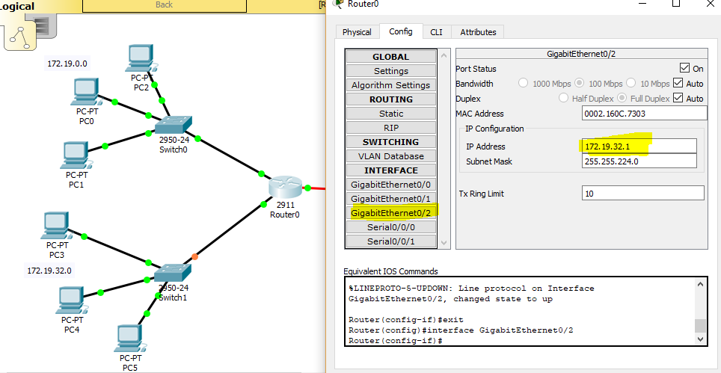

**TAKING Router 2**

* 4 connection
* 2 with switches and 2 serial connection

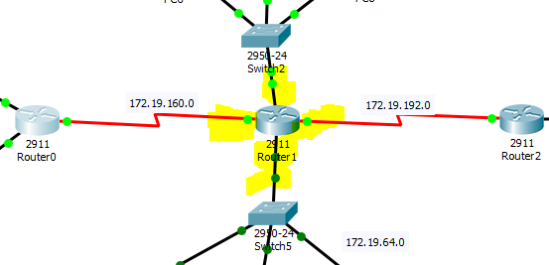

Giga 0/0 connection ( Router 2 with Switch 1)

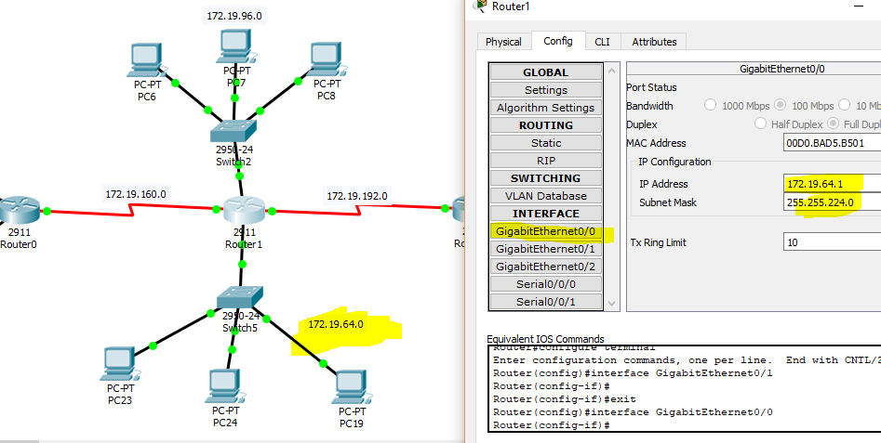

Giga 0/1 connection ( Router 2 with Switch 2)

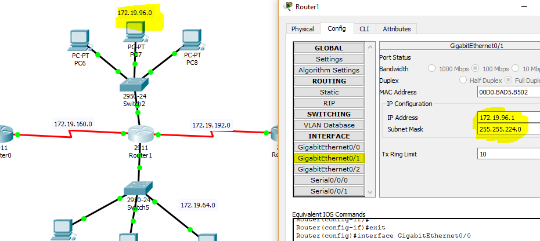

Serial 0/0/0 connection ( Router 2 with Router 1)

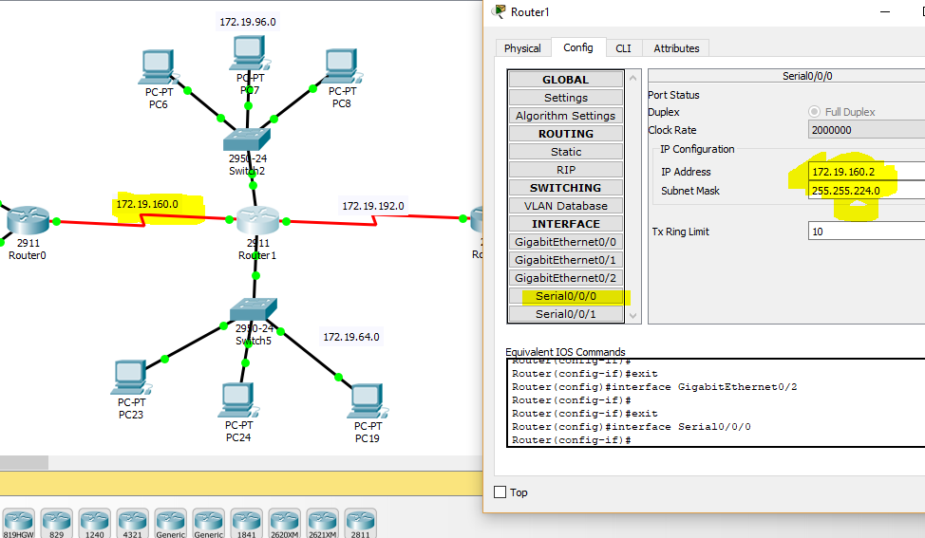

Serial 0/0/1 connection ( Router 2 with Router 3)

